1.Security Groups Vs Network ACLs:
Feature | Security Group | Network ACL (NACL)
Level | EC2 instance/network interface | VPC subnet
Traffic rules | Allow rules only | Allow and deny rules
Connection type | Stateful | Stateless
Return traffic | Automatically | Must be explicitly allowed
Rule evaluation | All applicable rules considered | Lowest numbered matching rule is applied first.
Main purpose | Control traffic to individual resources | Provide an additional subnet-level security layer.

2. AWS billing cost check:
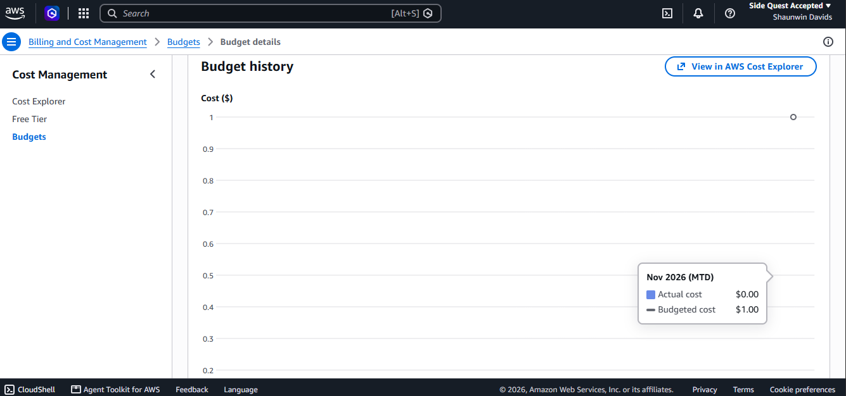
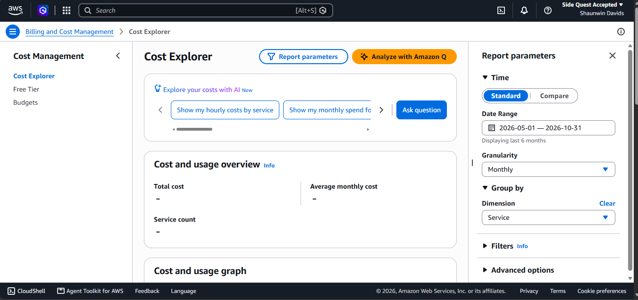

4.Report:
I reviewed my AWS billing dashboard to check the costs generated by the cloud resources used during the practical activities. I checked the charges by service and compared the current spending with my monthly budget. This helped me understand why cost monitoring is important when working with cloud services. I will continue monitoring the account and remove unused resources after completing the required evidence.

5.LinkedIn post:
Post | LinkedIn

